**主题词汇练**

**主题词汇展**

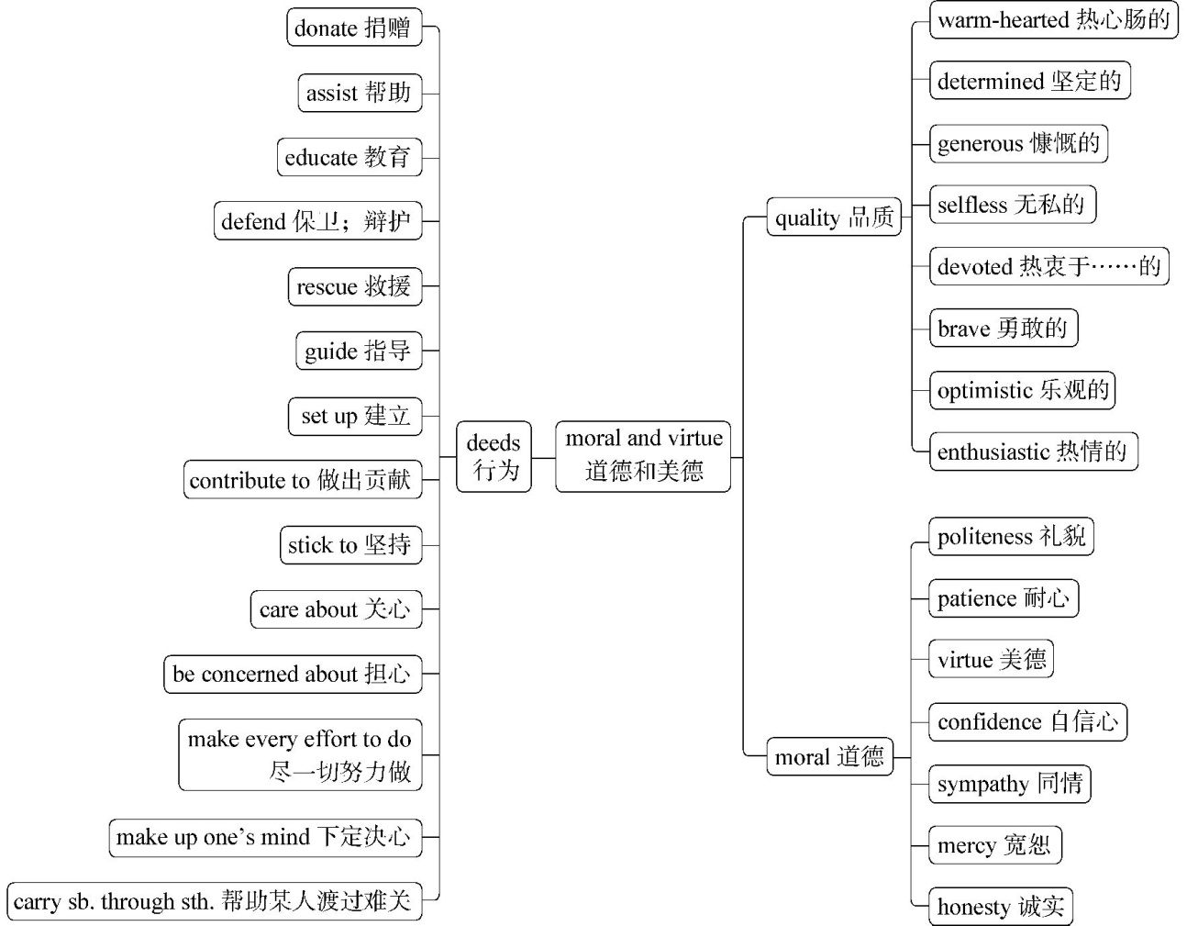

**语境演练场**

**语段填词**

1.Tom, a famous doctor, has many 　①　(品质). He is 　②　(热情的) about his work and 　③　(热衷于……的) to developing medicine and helping patients. He is 　④　(热心肠的) and 　⑤　(无私的) and often 　　⑥　　(帮病人渡过难关) difficulties. He is also 　⑦　(慷慨的) and often 　⑧　(捐献)money to charities. He is 　⑨　(坚定的) and can face challenges 　⑩　(勇敢地). Faced with difficulty, he is  　(乐观的).

①　　　 ②　　　 ③　　　 ④　　　 ⑤

⑥　　　 ⑦　　　 ⑧　　　 ⑨　　　 ⑩　　　 

2.The educator has 　　①　　(做出巨大贡献) the development of education.He 　　②　　(关心) the education of children. To 　　③　　(帮助) more children to go to school, he has 　　④　　(建立)more than 100 schools. He has 　　⑤　　(尽一切努力做) learn advanced teaching theories and 　　⑥　　(坚持)doing researches. He has 　　⑦　　(下定决心指导) more schools to improve the quality of education.

①　　　 ②　　　 ③　　　 ④　　　 ⑤

⑥　　　 ⑦

**答案全解全析**

**主题词汇练**

1.①qualities　②enthusiastic　③devoted　④warm-hearted

⑤selfless　⑥carries patients through　⑦generous　⑧donates

⑨determined　⑩bravely　optimistic

2.①contributed greatly to　②cares about　③assist　④set up　⑤made every effort to　⑥stick to　⑦made up his mind to guide