**主题词汇练**

**主题词汇展**

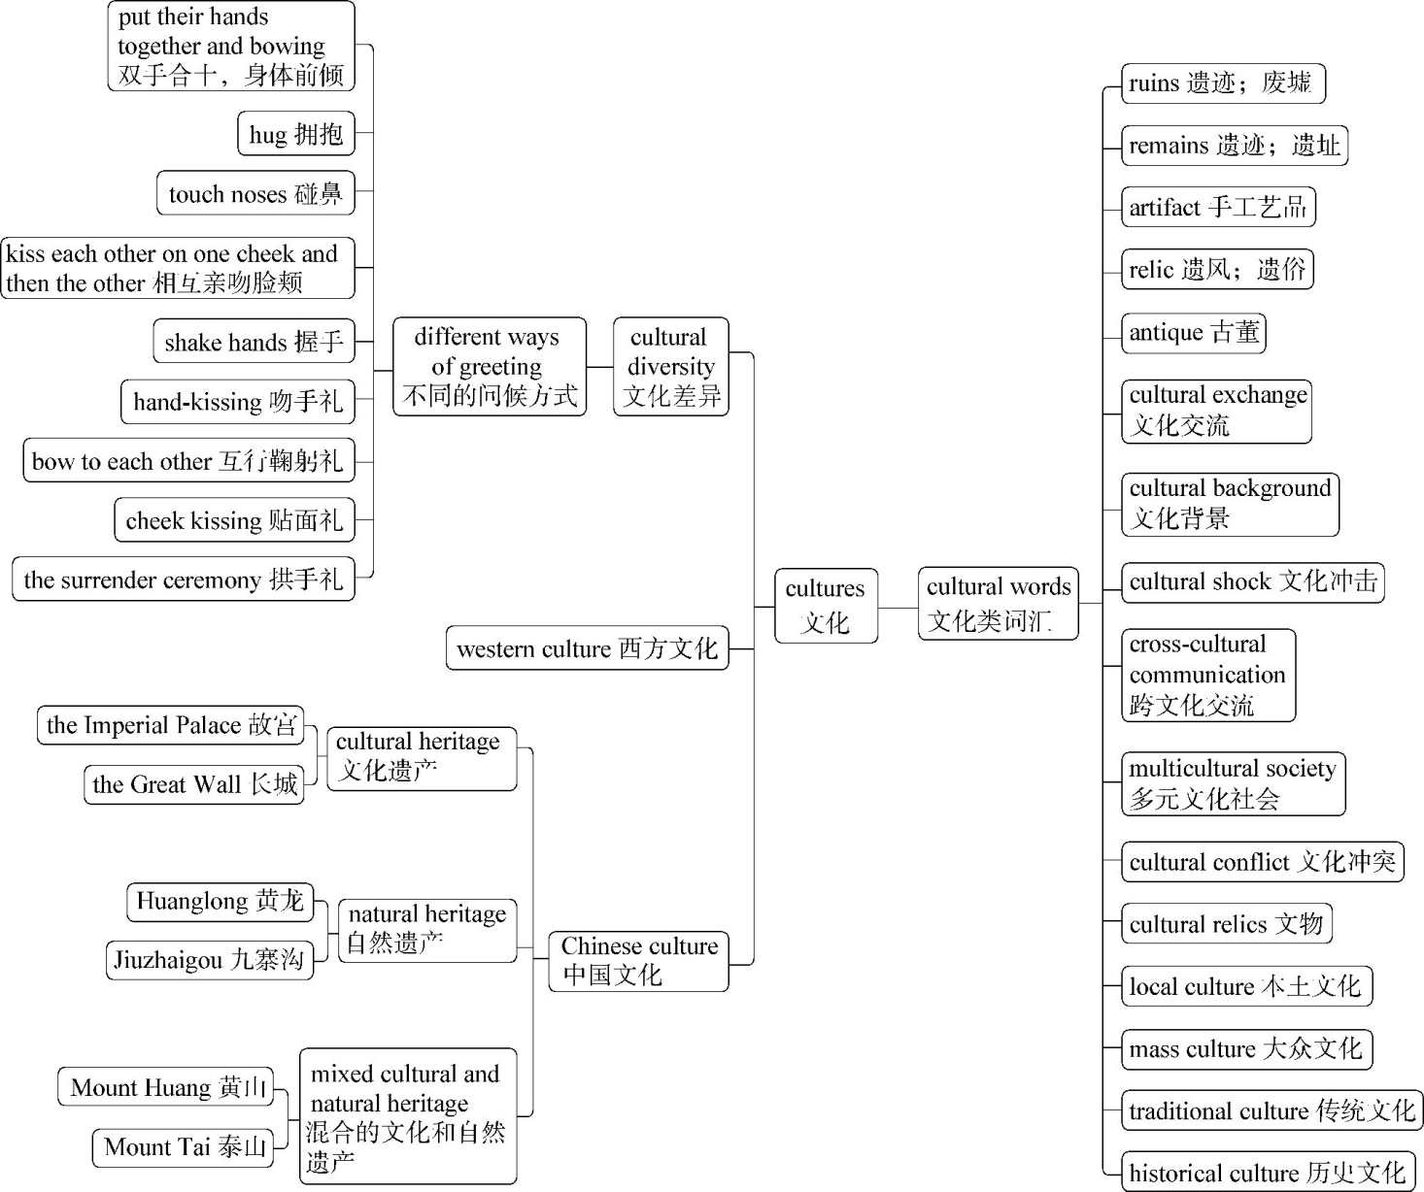

**语境演练场**

**语段填词**

There are many different ways of 　1　(问候)in the world. In Thailand, people greet each other by 　2　(双手合十)and 　3　(身体前倾)slightly. In South America, you can expect to 　4　(被拥抱)when you meet someone. In the Middle East, Arabs greet each other by 　5　(碰鼻). In the USA, people 　6　(握手) when meeting each other. In France, it is the custom to shake hands with people in the office every morning. When Dutch people meet, they 　7　(亲吻)each other on one cheek and then the other. If you are a close friend or relative, then you will get three kisses! In Japan, people 　8　(互行鞠躬礼)when they meet.

1.　　　　2.　　　　3.　　　　4.

5.　　　　6.　　　　7.　　　　8.

**答案全解全析**

**主题词汇练**

1.greeting　2.putting their hands together　3.bowing　4.be hugged

5.touching noses　6.shake hands　7.kiss　8.bow to each other