**主题词汇练**

**主题词汇展**

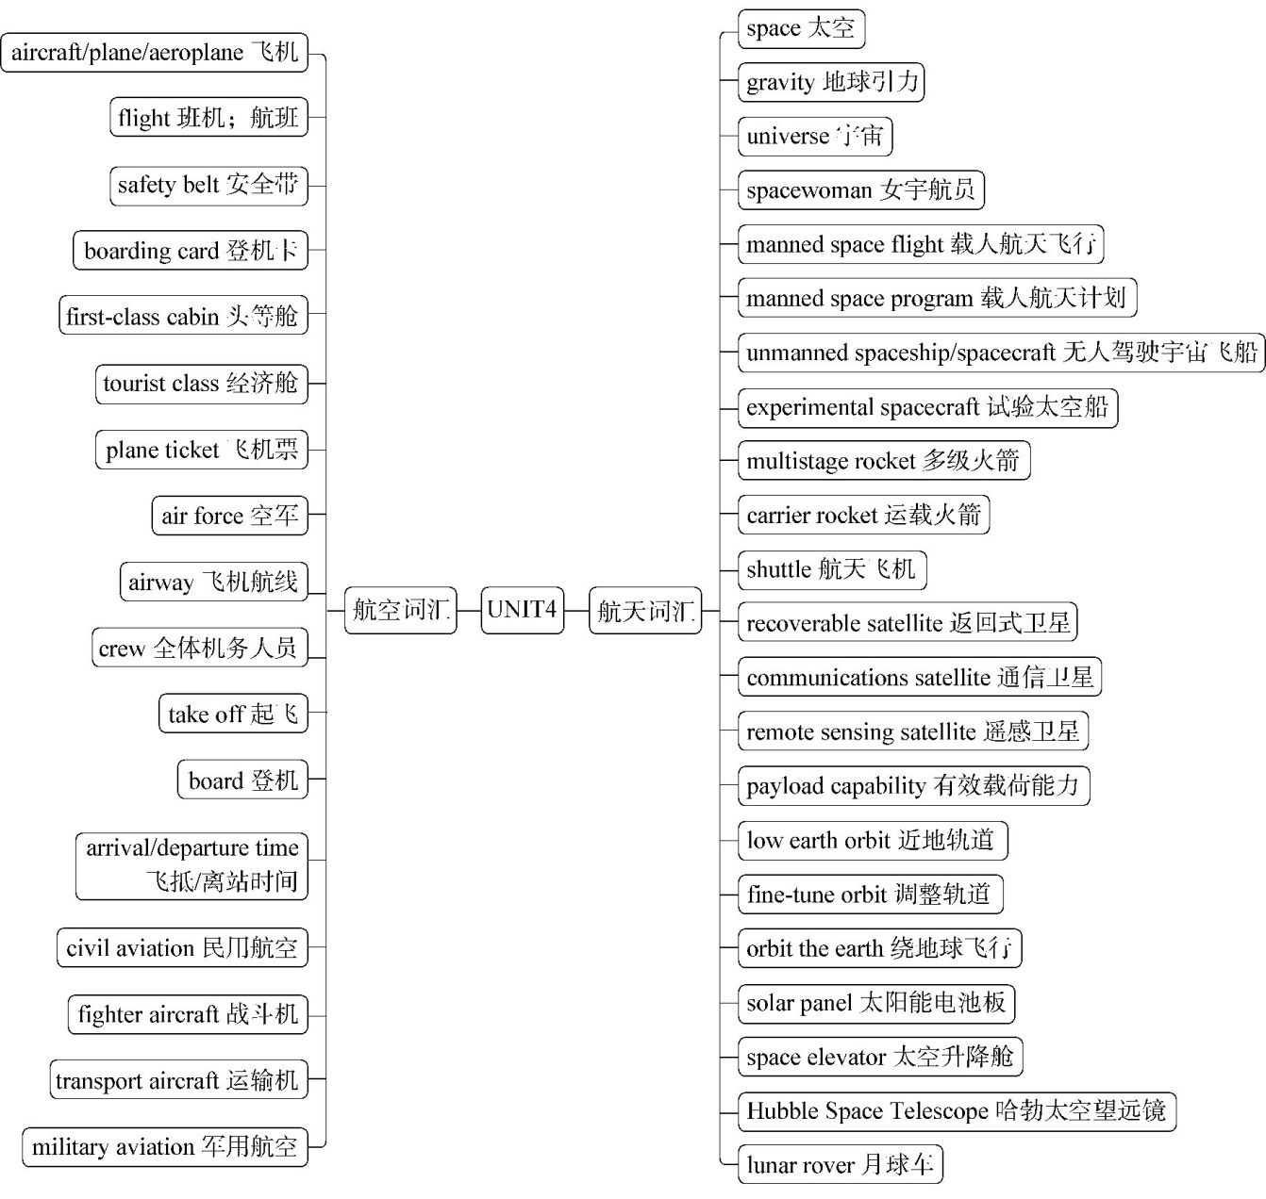

**语境演练场**

**语段填词**

　　Thirty-three-year-old 　1　(女宇航员) Wang Yaping will make history—she will be China’s first teacher in　2　(太空). Wang will teach Chinese primary and middle school students on Earth physics phenomena in a zero-　3　(地球引力)environment. She is preparing for the lecture and expressed full confidence about the upcoming lesson. Meeting the media Monday, she said,“We are all students in facing the vast 　4　(宇宙). We are looking forward to joining our young friends to learn and explore the mystical and beautiful universe.”Wang, born in January 1980, is from east China’s Shandong Province, the hometown of China’s most famous educationist Confucius (551—479 BC). She was a transport 　5　(飞机) pilot in the People’s Liberation Army (PLA)　6　(空军)with experience of 1,600 hours of flying.

The world’s first teacher in space was Christa McAuliffe, a 37-year-old middle school teacher from the United States, but the 　7　(航天飞机) Challenger disintegrated 73 seconds after lifting off on January 28, 1986. McAuliffe and other six 　8　(全体机务人员) members were killed.

1.　　　 2.　　　 3.　　　 4.　　　 5.

6.　　　 7.　　　 8.

**答案全解全析**

**主题词汇练**

1.spacewoman　2.space　3.gravity　4.universe　5.aircraft/plane/aeroplane　6.Air Force　7.shuttle　8.crew